**Part 1**

Section -1 Product Sales



Section -2 Product Cost of Sale

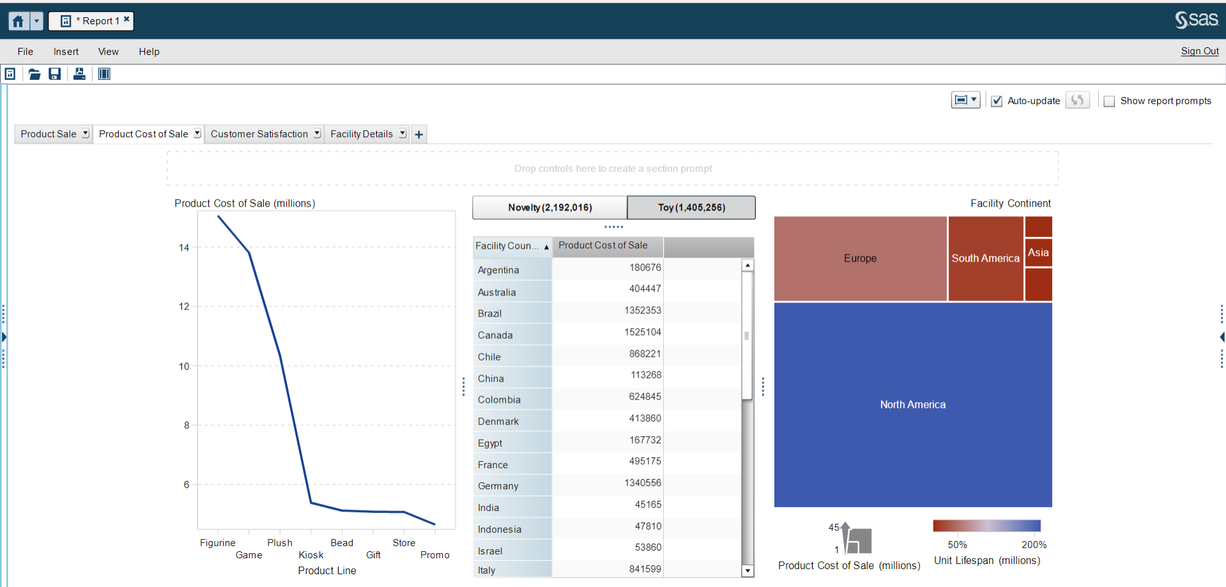

Section 3 – Customer Satisfaction

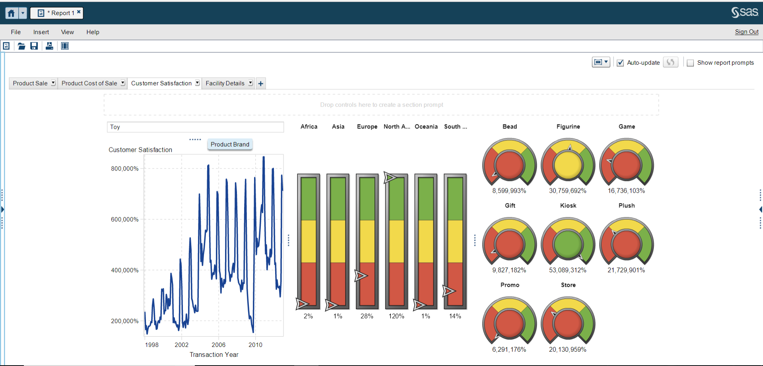

Section 4 – Facility Details and Misc

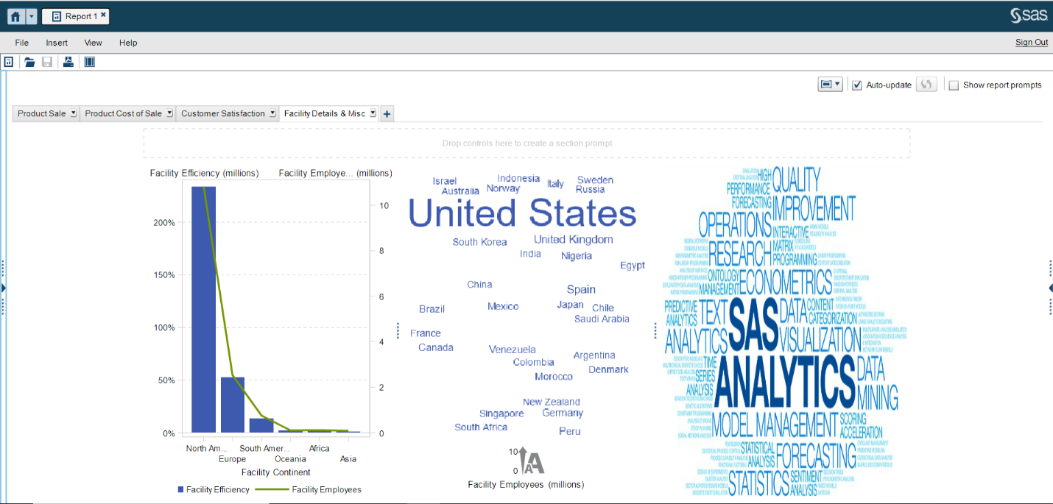

**Part -2**

**H1: The weight and cholesterol levels are correlated**

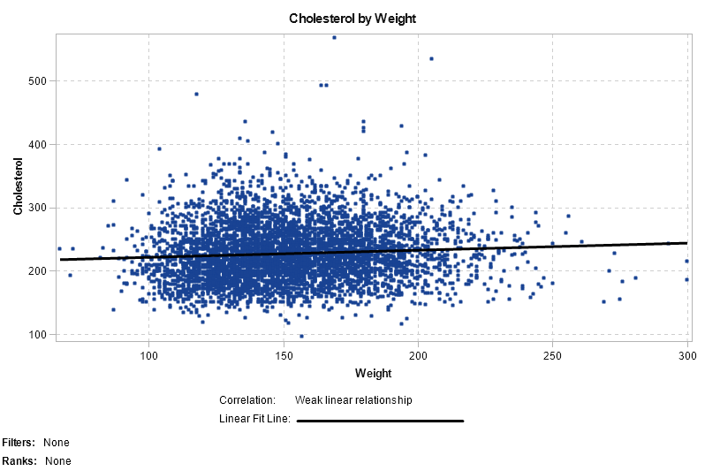

True, because as the weight increase the linear fit line also shows a slight increase in the cholesterol. Although it’s a very weak linear relationship but there is a slow increase in cholesterol. Therefore, weight and cholesterol levels are correlated.

**H2: Men are usually more obese than women**

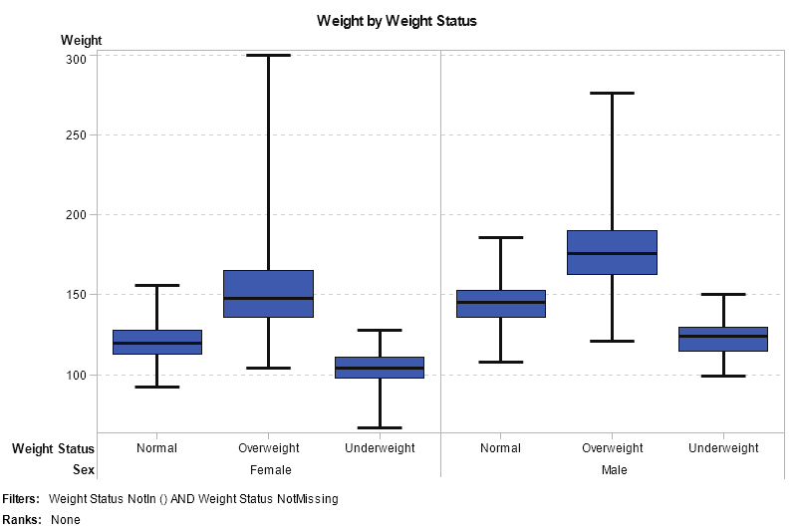

True, as the box plot depicts that the males have more weights in overweight category, along with the other categories. Therefore, men are more obese than women.

**H3: Women usually smoke less than men, but their cholesterol level is higher**

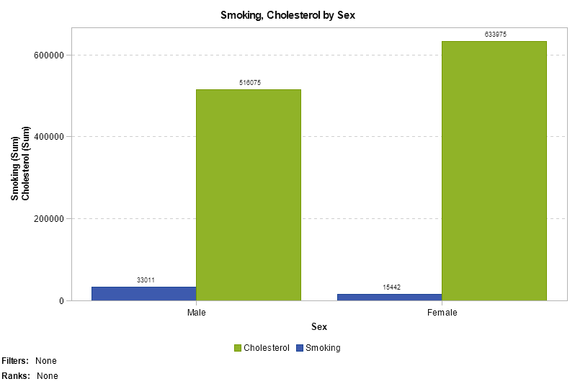

True, this hypothesis holds true because the comparison between cholesterol and smoking shows that clearly women have low smoking level, simultaneously they have higher cholesterol as compared to males.

**H4: The blood pressure is higher for people with higher cholesterol levels**

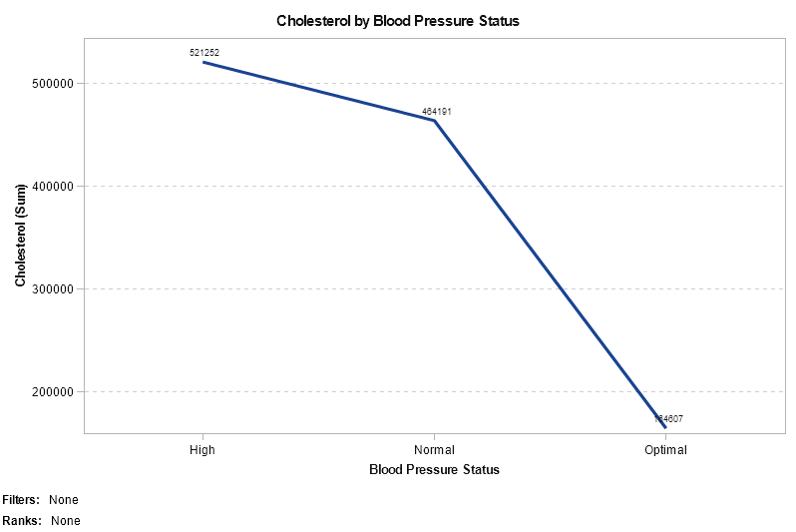

True, the blood pressure is higher for people with higher cholesterol levels, as seen in the line graph that the blood pressure increases as there is a rise in cholesterol and therefore, the blood pressure is at the highest for people with high cholesterol.

**H5: Heavy smokers tend to die faster than moderate and non-smokers**

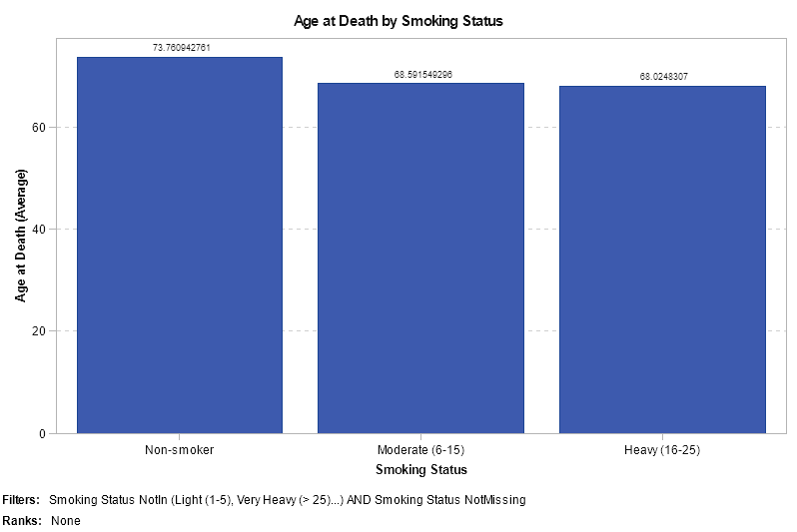

True, heavy smokers die faster than moderate and non-smokers, as seen in the bar graph, the age at death for heavy smokers is the least as compared to the other two.

**H6: Most non-smokers are overweight**

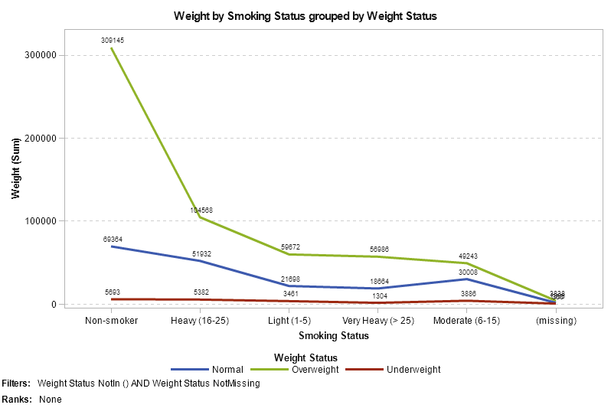

True, most non-smokers are overweight as the line graph shows that with all the smoking categories, non-smokers have the highest value with the overweight status category.

**H7: Correlation between weight and height is lower in women than in men**

Females

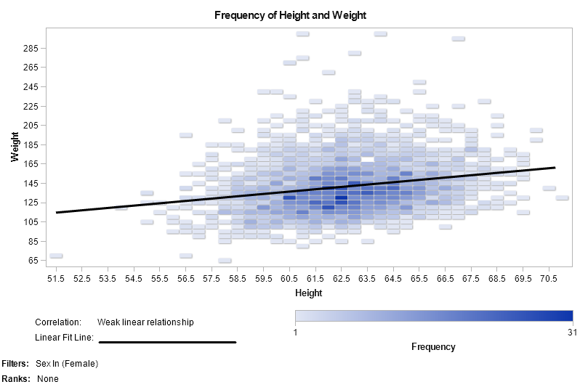

Males

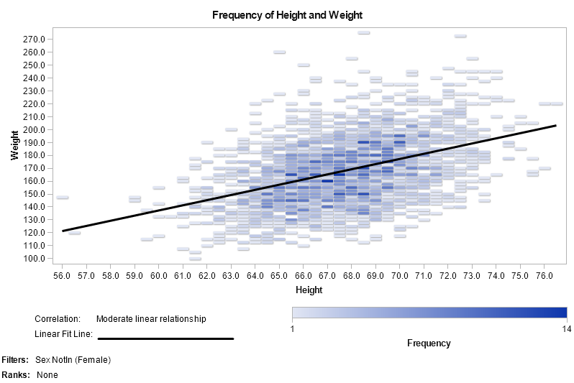

True, because as we can see from the graphs, the correlation between height and weight in males is moderate and for females, it is a weak relationship. Therefore, correlation between weight and height is lower in women than in men.

**Coronary Heart Disease (CHD)**

Coronary heart disease can be caused by following factors-

1. High blood pressure
2. Higher cholesterol level
3. Overweight
4. Smoking.

As per the analysis, CHD is diagnosed at the average age of 65 for women and 61 for men.

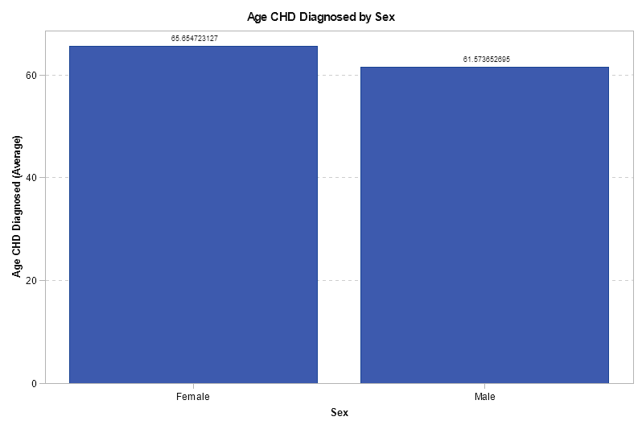

**High blood pressure**

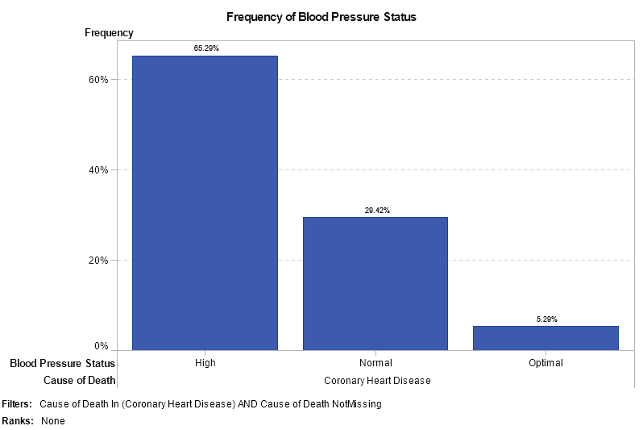

The bar graph shows that 65.29% people suffering from high blood pressure have died by Coronary heart disease, as compared to people with normal and optimal blood pressures.

**High Cholesterol level**

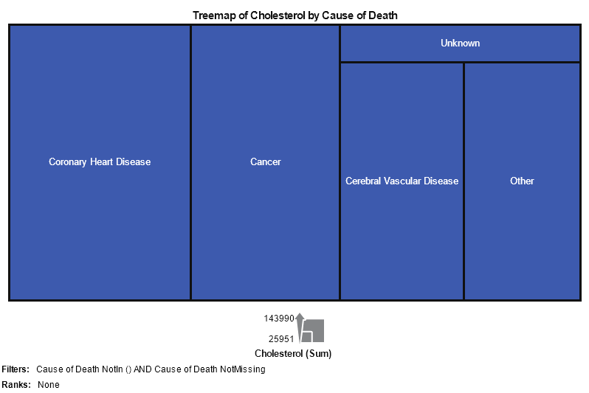

The treemap shows that high cholesterol is one of the reasons for the death by Coronary Heart disease, out of all other causes, CHD shows the highest cholesterol level when compared to the other causes of death from the data.

**Overweight**

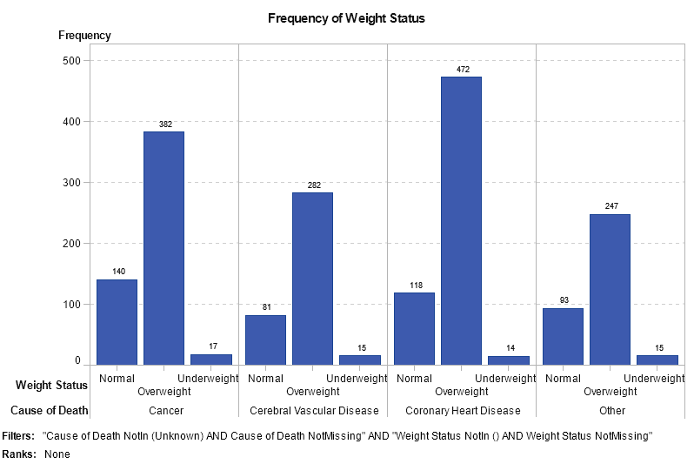

The bar graph shows that overweight is one of the major reasons for death with Coronary heart diseases, along with that for other diseases as well, it is one of the major reasons for the death. According to the data 472 people have died due to overweight.

**Smoking**

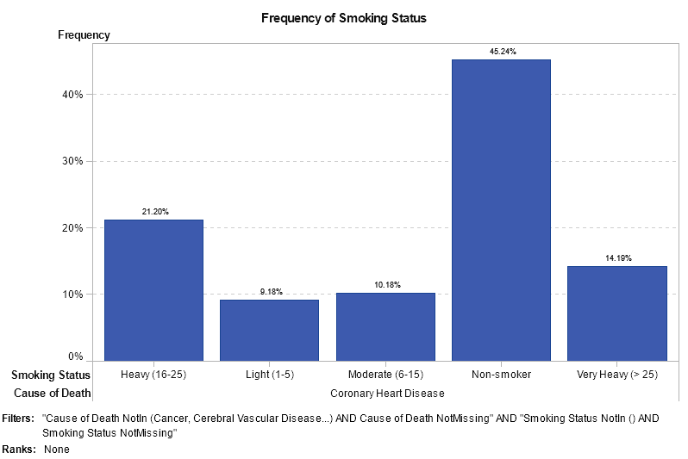

The bar graph shows the percent of CHD deaths were the main non-smokers status is 45.24% which shows irrespective of the smoking habits where there are heavy smokers, moderate smokers and light smokers, CHD can affect non-smokers too.